

Project about

**PlayStation App**

|  |  |  |
| --- | --- | --- |
| Student Number | Student Name | N |
| 00000000 | سعد عبد الله إبراهيم السهلي | 1 |
| 00000000 | محمد معجب محمد الدوسري | 2 |
| 00000000 | ريان محمد عبيد الشريف | 3 |
| 00000000 | ناصر حمد ناصر ال ذيبان | 4 |

**د.محمد سعد محمد العسيري Supervised by :**

**Year: 2023**

*INDEX*

|  |  |
| --- | --- |
| **Page** | **Content** |
| **3** | Feasibility Study &Project Proposal |
| **5** | Project requirements |
| **6** | Activity diagram |
| **8** | Project Use Case Modelling |
| **12** | Sequence Diagrams |
| **14** | Class Diagram |

**Introduction**

It is a software application for iOS and Android devices that allows us to identify connected friends or view progress or compare awards with friends or create a personal profile to display to friends. The first version of the application was released on November 15 / 2013.

**Problems**

1-You can't download games without Turn on a PS console

2-You can't message your friends without Turn on a PS console

3-Miss the latest PlayStation news without Turn on a PS console

4-You cannot play/delete your PS games without Turn on a PS console

**Background**

Sony Corporation is a Japanese electronics company, founded by Masaru Buka in 1946, under the name "Tokyo Communications Engineering Corporation". It is also one of the world's largest manufacturers of consumer electronic products

**Proposed solution**

1-Download games to your PS console remotely

2- Message your friends and coordinate group gaming sessions

3- Keep up with the latest PlayStation news

4- Launch/ Delete Your PS Games Remotely

**Work Plan**

In the PS App application, we will use the Incremental model of application development where the application is developed in successive stages

1 – **Determine requirements**

Application requirements are determined by collecting information from players and developers

**2 – Design**

The application is designed according to the requirements specified in the first stage

**3 – Implementation**

Design is performed like writing code or testing an application

**4 – validation**

It is verified that the application meets the requirements

**5 – Evolution**

The necessary modification are being made to the application based on feedback from players and developers

The application targets two categories of society :

**1 – Players:** the application allows players to purchase games or communicate with players

**2 – Developers:** the application provides a set of tools and resources that help them display games or announce upcoming updates

**Project requirements**

**Functional requirements:**

1- The system must allow the player to log in using their (email and password).

2- The system must send a verification message to verify the player's identity.

3- The system must allow the player to use a unique name that has not been used before.

4- The system can allow the player to view his downloaded games.

5- The system can allow the player to delete his games.

6- The system can allow the player to add new games.

7- The system can allow a player to create a message to others.

8- The system must allow the player to add another player.

9- The system's ability to send announcements about events occurring at a specific time.

10- The system must allow the game developer to Download game in store.

11- The system must allow the game developer to delete game in store.

12- The system allows the game developer to modify (the shape, cover, color, and settings) of the game.

13-The system allows the player’s close friends to view his real name.

14-The system allows the player to rate games

The system allows the developer to see how players rate his product.

15-The system allows the developer to download a trial version of the game.

16-The system allows players to download trial games.

17-The system allows players to charge the digital wallet balance from the application.

**Non-functional requirements:**

1- The running time of the application should not exceed four minutes.

2- The system must enable the player to perform several tasks without reducing performance and efficiency.

3- The possibility of easy navigation and use for users.

4- Every user account must be secure and not accessible to unauthorized persons.

**Activity diagram:**

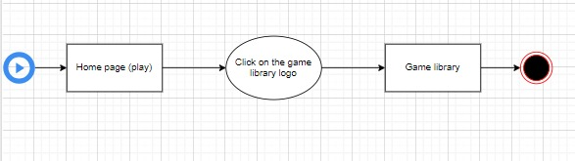(View games)

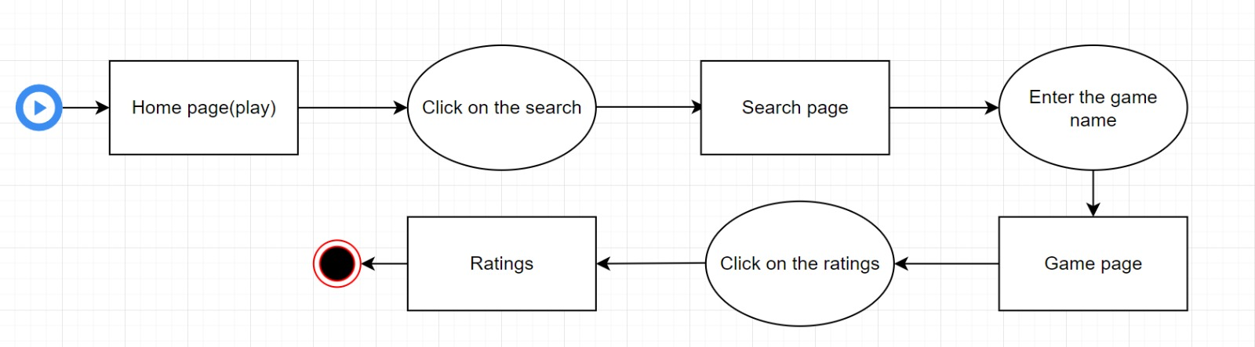Review player ratings))

(Communicate with users)

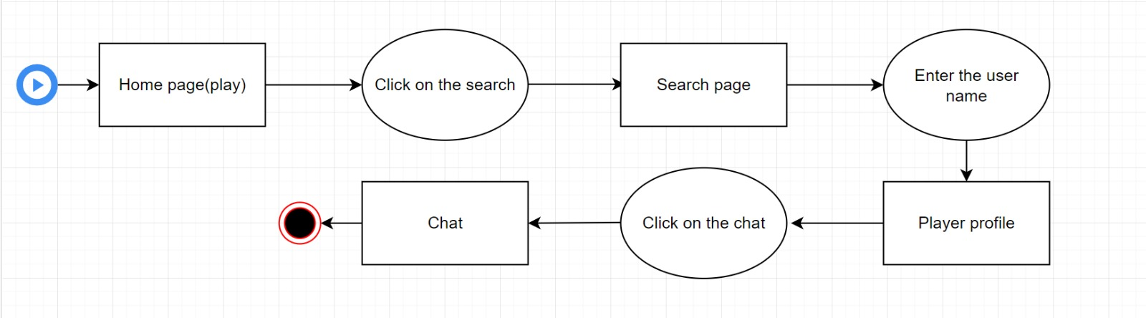

**Project Use Case Modelling:**

|  |  |
| --- | --- |
| Roles | Actors |
| - Create announcements  - Communicate with users  - Update system designs | **Admin** |
| - View games  - Rate games  - Voice chat with friends | **User** |
| - Review player ratings  - Release games  - Update games | **Development** |

**Actor:**

**Use cases &its related use cases:**

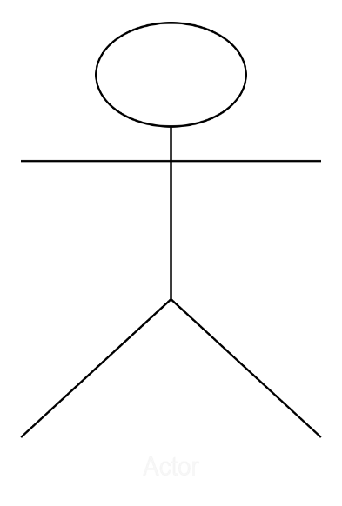

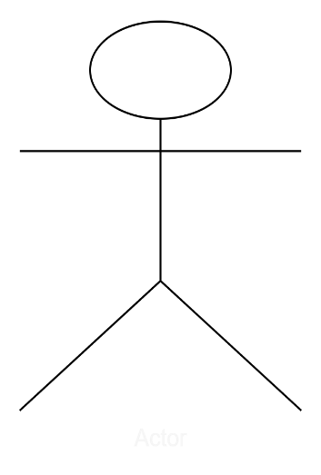

*Admin*

*Development*

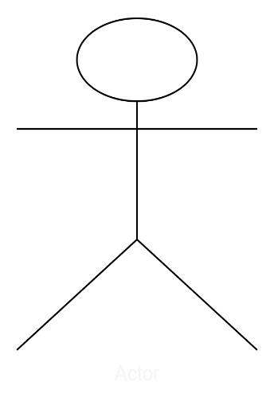

frfrfvrtu

*user*

**Table 1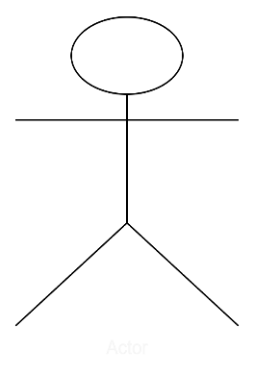:**

*Database of games*

*User*

|  |  |  |
| --- | --- | --- |
| **User : View Games** | | |
| User and DB of games | **Actors** |
| It explains the interaction of the user (the player) and the way he views the games he has and those in the database designated for me to store games. | **Description** |
| User email, User password, Game code, And Verification code | **Data** |
| Want to view the games. User | **Stimulus** |
| Games information (Name, code) | **Response** |
| No Comments**.** | **Comments** |

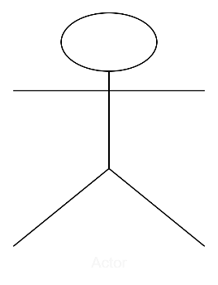Table 2:

*Admin*

*Database of User*

|  |  |  |
| --- | --- | --- |
| **Admin:**  **Communicate with users** | | |
| Admin and DB of User | **Actors** |
| It explains the admin's method of communicating with users and helping them with any technical problem they face, as well as responding to their inquiries. | **Description** |
| User name, user ID, user email, admin ID. | **Data** |
| Want to Communicate with users Admin. | **Stimulus** |
| Helping them by (communicating with them, solving problems, and protecting users) | **Response** |
| No Comments**.** | **Comments** |

**Sequence Diagrams:**

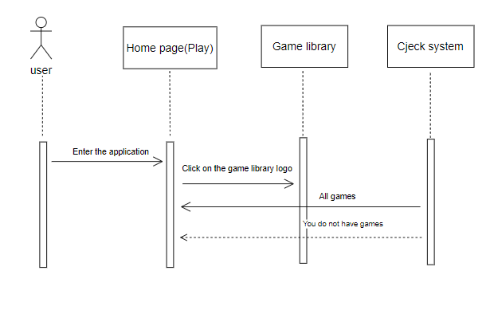View games))

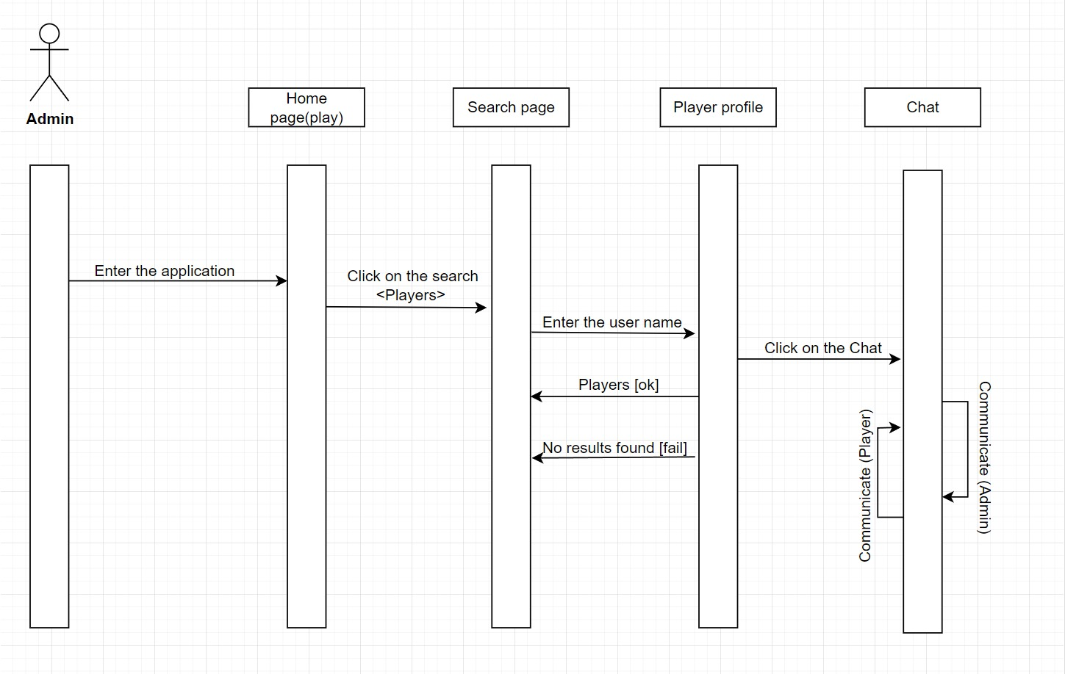Review player ratings))

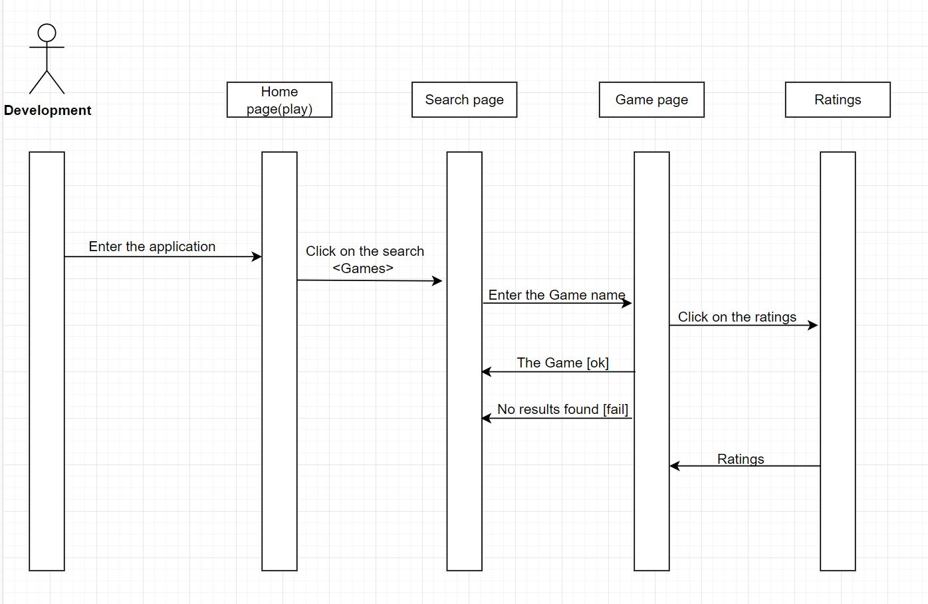Communicate with users))

|  |
| --- |
| Class user(player) |
| Contact ID (Int)-  Name (String)-  -Emile (String)  - Nickname (String)  -Address (String)  -phone # (Int)  -Bank account (Int)  -password (Int)  - language (String)  -country (String) |
| -New account ()  -Add ()  -Delete ()  -Update ()  -Search ()  -download ()  - Review () |

|  |
| --- |
| Class games |
| -ID(Int)  -Name (String)  -Version (Int)  -Age classification (Int)  -Developer name (String)  -Date created (Date)  -Operator type (Int)  -Type game (String)  Abstract (String)- |
| -add ()  -delete ()  -Update ()  -Review ()  -maintenance () |

**Class Diagram:**

|  |
| --- |
| Class Developer |
| -ID(Int)  -Name (String)  -Game id(int)  -Name game (String)  - license number (Int)  -Address (String)  -Email (String) |
| -Add ()  -delete ()  -Update ()  -Review ()  -maintenance ()  -Support ()  -Design () |

